TRIANGLE Project
Form:
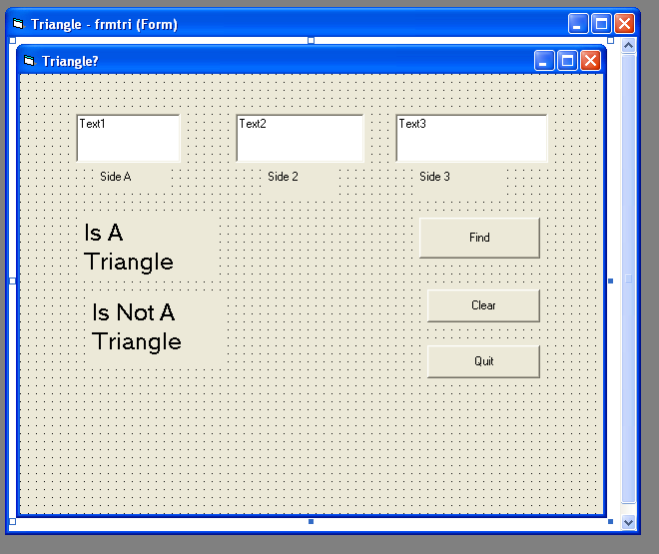
Code:
Private Sub cmdfind_Click()
Dim a As Integer, b As Integer, c As Integer
a = Val(txta)
b = Val(txtb)
c = Val(txtc)
If a + b > c And a + b > c And a + b > c Then
lblis.Visible = True
' This is where the rest of the tests for what kind of triangle will go'
Else
lblisnot.Visible = True
End If
End Sub
Grading Rubric:

“B” *Test for triangle
*Test for kind of triangle
- equilateral
- isosceles
- scalene
- right
________________________________________________________________
“A” - obtuse
- acute
*Area and Perimeter
*Angles
*Pictures and/or diagrams

